# Section 6.1: Areas Between Curves

We have seen how to calculate the area below a curve on a given interval. In this section, we expand that idea to calculate the area of more complex regions.

## Area of a Region between Two Curves

**Finding the Area between Two Curves**

Let $f(x)$ and $g(x)$ be continuous functions such that $f(x)≥g(x)$ over an interval $[a,b]$.

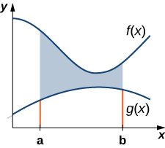

Let $R$ denote the region bounded above the graph of $f(x)$, below by the graph of $g(x)$, and on the left and right by the lines $x=a$ and $x=b$, respectively. Then, the area of $R$ is given by

$A=\int_{a}^{b}{\left[f\left(x\right)-g(x)\right]}dx$.

Media: Watch these [video1](https://youtu.be/q7De3oOp4Ug) and [video2](https://youtu.be/BH-V6Gx2n8E) examples on finding areas between curves.

Examples

1. Determine the area of the region between the two curves in the given figure by integrating over the $x$-axis.

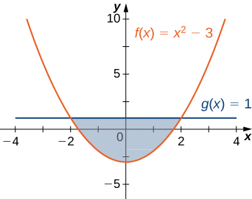

1. If $R$ is the region bounded above by the graph of the function $f\left(x\right)=x+4$ and below by the graph of the function $g\left(x\right)=3-\frac{x}{2}$ over the interval $[1,4]$, find the area of region $R$.
2. If $R$ is the region bounded above by the graph of the function $f\left(x\right)=9-{\left(\frac{x}{2}\right)}^{2}$ and below by the graph of the function $g\left(x\right)=6-x$, find the area of region $R$.

## Areas of Compound Regions

So far, we have required $f(x)≥g(x)$ over the entire interval of interest, but often times the regions of interest are not simple.

**Finding the Area of a Region between Curves That Cross**

Let $f\left(x\right)$ and $g(x)$ be continuous functions over an interval $[a,b]$. Let $R$ denote the region between the graphs of $f(x)$ and $g(x)$, and be bounded on the left and right by the lines $x=a$ and $x=b$, respectively. Then, the area of $R$ is given by

$A=\int_{a}^{b}{\left|f\left(x\right)-g(x)\right|}dx$.

Media: Watch this [video](https://youtu.be/lskEXsJaJV0) example on finding areas with multiple regions.

Examples

1. If $R$ is the region between the graphs of the functions $f\left(x\right)=\sin{x}$ and $g\left(x\right)=\cos{x}$ over the interval $[0,π]$, find the area of region $R$.
2. Consider the region shown below. Find the area of $R$.

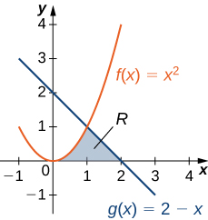

## Regions Defined with Respect to $y$

We can also find the area between two graphs with respect to $y$. Sometimes this method is easier to evaluate rather than evaluating multiple integrals to calculate the area of a region.

**Finding the Area between Two Curves, Integrating along the $y$-axis**

Let $u(y)$ and $v(y)$ be continuous functions such that $u(y)≥v(y)$ for all $y∈[c,d]$. Let $R$ denote the region bounded on the right by the graph of $u(y)$, on the left by the graph of $v(y)$, and above and below by the lines $y=d$ and $y=c$, respectively.

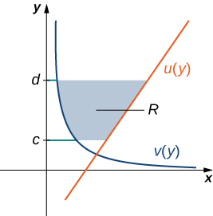

Then, the area of $R$ is given by

$A=\int_{c}^{d}{\left[u\left(y\right)-v(y)\right]}dy$.

Media: Watch this [video](https://youtu.be/70NQ3ISYihw) example on finding areas with respect to $y$.

Example: Consider the region shown below. Integrate with respect to $y$ to find the area of $R$.

